**COVID EMERGENCY EVACUATION**

**PURPOSE**

The purpose of this policy is to establish clear instructions when an emergency arises requiring evacuation of the building during COVID lockdown.

**SCOPE**

The scope of the policy shall apply to all employees of Diebold Nixdorf including contractors and visitors, during the COVID lockdown, on how to evacuate the building as quickly and safely as possible.

**PROCEDURE**

**When the ALARM sounds**:

* **Do not hesitate** – gather yourself and head to the **nearest exit.**
* **Use the stairs**. Never use the elevators during an emergency.
* Go directly to the parking lot along railroad tracks and gather between the letters “B & C” Area sign. Please see map attached.
* Call “911” to report the emergency if necessary.
* If you think someone may be trapped inside, please let Security/Office Manager know.
* Security/Office Manager will have the daily “Sign-In / Sign-Out” sheet and will take attendance to confirm that everyone is out safely.
* **Do not go back inside – for any reason – until the firefighters say it is safe**

**If you are trapped:**

* Call “911” to tell the dispatcher where you are in the building.
* Stuff clothes or towels in the cracks around the doors.
* Wait at a window for the fire department to rescue you, if at all possible.

**Escape tips:**

* Close doors behind you as you escape, to slow the spread of fire and smoke.
* If you have to escape through smoke, crawl on your hands and knees. Keep your head 0.3 to 0.6 metres (1-2 feet) above the floor where the air will be the cleanest.
* Test doors, doorknobs and spaces around the door with the back of your hand. If the door is warm, try another escape route. If it is cool, open door slowly. Slam door shut if smoke enters through the door.

**RESPONSIBILITIES**

**Security / Office Manager**

* Lock up front desk drawers and Office Manager’s door.
* Collect 1st Aid Kit and AED
* Collect the daily “Sign-In / Sign-Out” sheets and any visitor sheets.
* Collect up-to-date employee contact information sheet to have if necessary.
* **Exit the nearest stairwell**, do not use elevators.
* Meet everyone at the parking lot along railroad tracks and gather between the letters “B & C” Area sign. Please see map attached.
* Once roll call is complete be sure that everyone stays at meeting spot.
* Attend to anyone with injuries, and if necessary, call “911” for an ambulance if one is not already there.
* When advised by the fire department, Security/Office Manager will announce that it is safe to re-enter the building.

**FIRE EXITS – THIRD FLOOR**

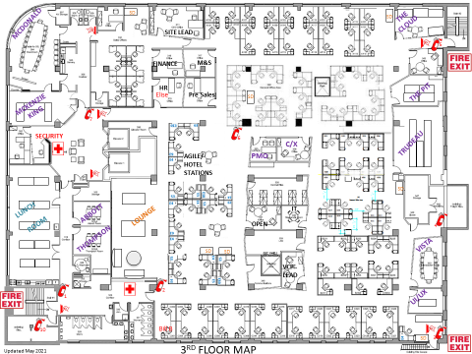

**FIRE EXITS – FIRST FLOOR**

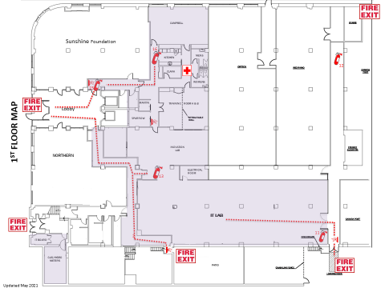

**BATHURST PARKING LOT MEETING AREAS**

**AREA BETWEEN B & C**

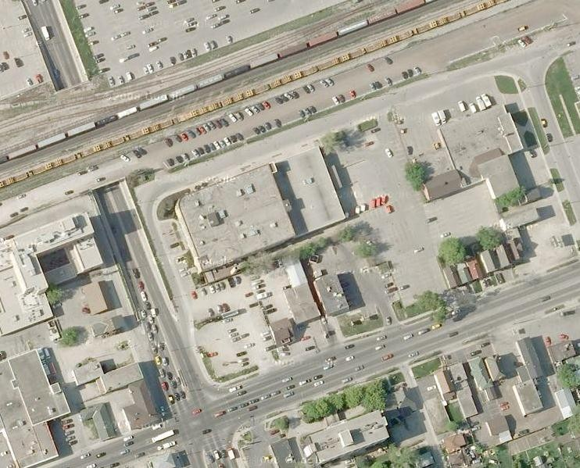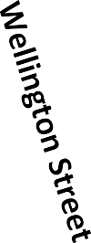

**EXIT**

**Front Entrance**

**Emergency Escape Stairs**

**EXIT**